**Module 5 Assignment Problem 1 (excel file as a source)**

Transformation:

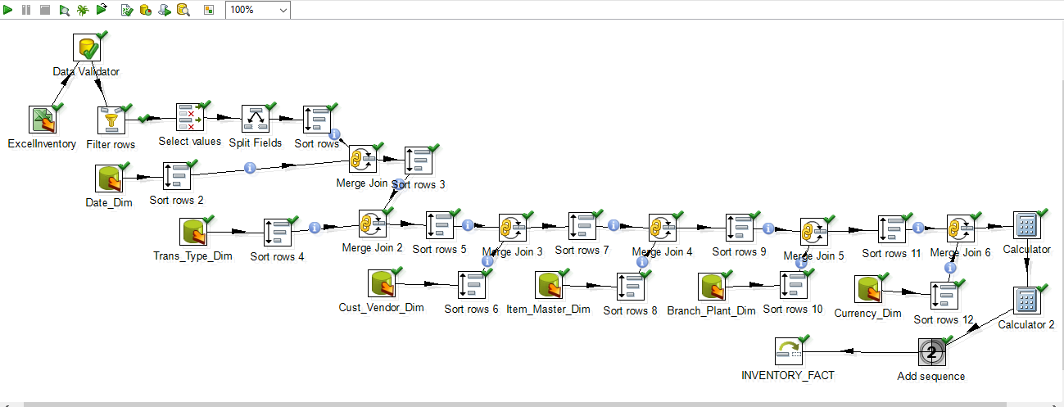

10 rows were inserted.

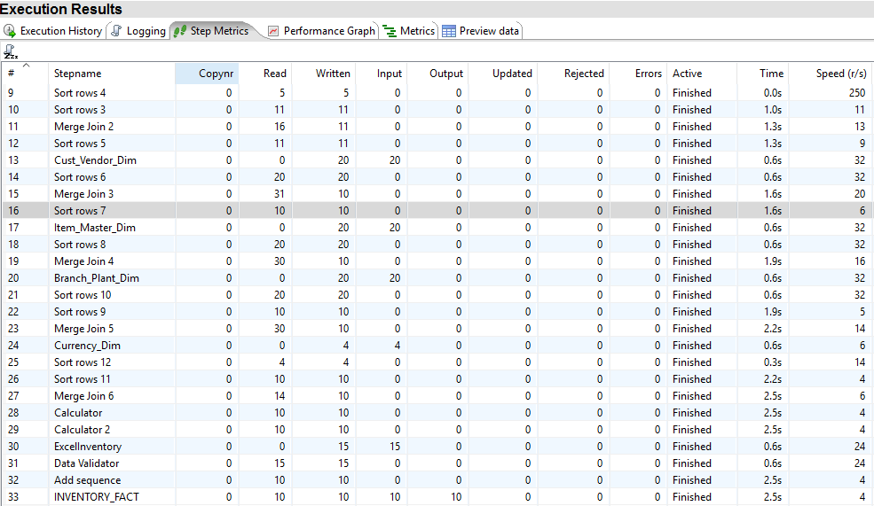

SQL screenshot -

